EXPERIMENT-10
Aim: Implementing Notification. Build an android application that sends notification to the user. Customize the appearance and behaviour of the notifications.
Theory:
Implementing notifications in Android involves using the Notification Manager and Notification Channels to deliver alerts to users even when the application is not actively in use. A notification is built using the NotificationCompat.Builder class, where developers can define elements such as title, message, icon, priority, and actions. For devices running Android 8.0 (API level 26) and above, notification channels are required to control the importance and behavior of notifications, such as sound, vibration, and visibility. Developers can customize the appearance using styles like BigTextStyle or InboxStyle, and enhance interaction by adding action buttons or pending intents to open specific activities. Proper handling of runtime permissions (like POST_NOTIFICATIONS in newer Android versions) ensures that notifications are displayed effectively while maintaining user privacy and control.

App Notifications Disabled (Device Setting) - Sometimes phone blocks notifications.
✔ Fix:
1. Go to Settings
2. Apps → Your App
3. Notifications → Turn ON
Use of POST_NOTIFICATIONS permission: This permission allows your app to “Send notifications to the user”
Why is it important?
Starting from Android 13 (API 33), Apps cannot show notifications without user permission. User must allow notification manually.
What happens without this permission?
Notification code runs but nothing is displayed.

Step 1: Create New Project
1. Open Android Studio
2. Click New Project
3. Select Empty Views Activity
4. Name: NotificationApp
5. Language: Java (or Kotlin if you prefer)
6. Click Finish

Step 2: Open res/layout/activity_main.xml and write code for widgets.

Step 3: Add Notification Code in MainActivity.

Step 4: Customize Notification
You can customize like this:
.setContentTitle("New Message ")
.setContentText("You have a new notification")
.setSmallIcon(android.R.drawable.star_on)
.setAutoCancel(true)
Add Sound / Vibration:
.setDefaults(NotificationCompat.DEFAULT_ALL)

Step 5: Add this in AndroidManifest.xml
<uses-permission android:name="android.permission.POST_NOTIFICATIONS" />

Note: - If nothing is displayed when you click the “Send Notification” button, don’t worry— this is a very common issue.

Code:
activity_main.xml
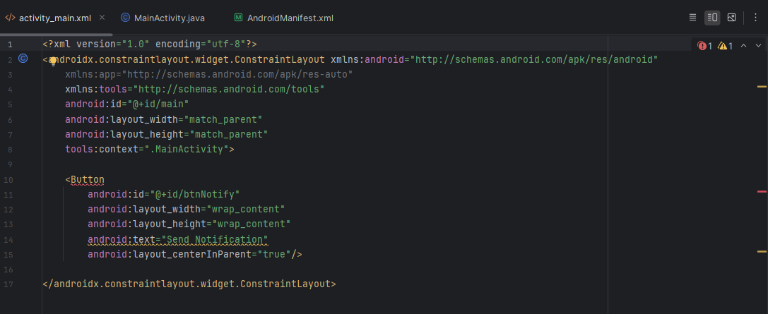

MainActivity.java
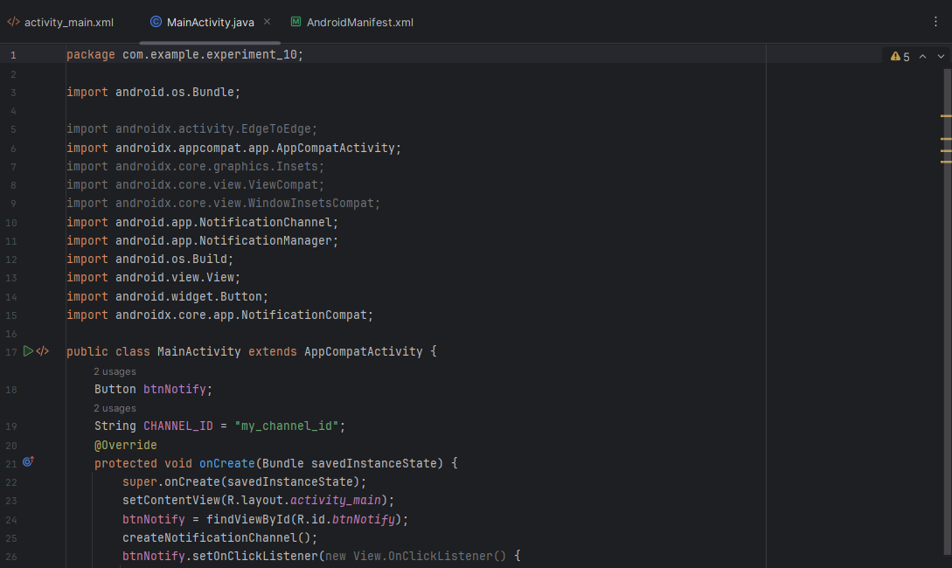
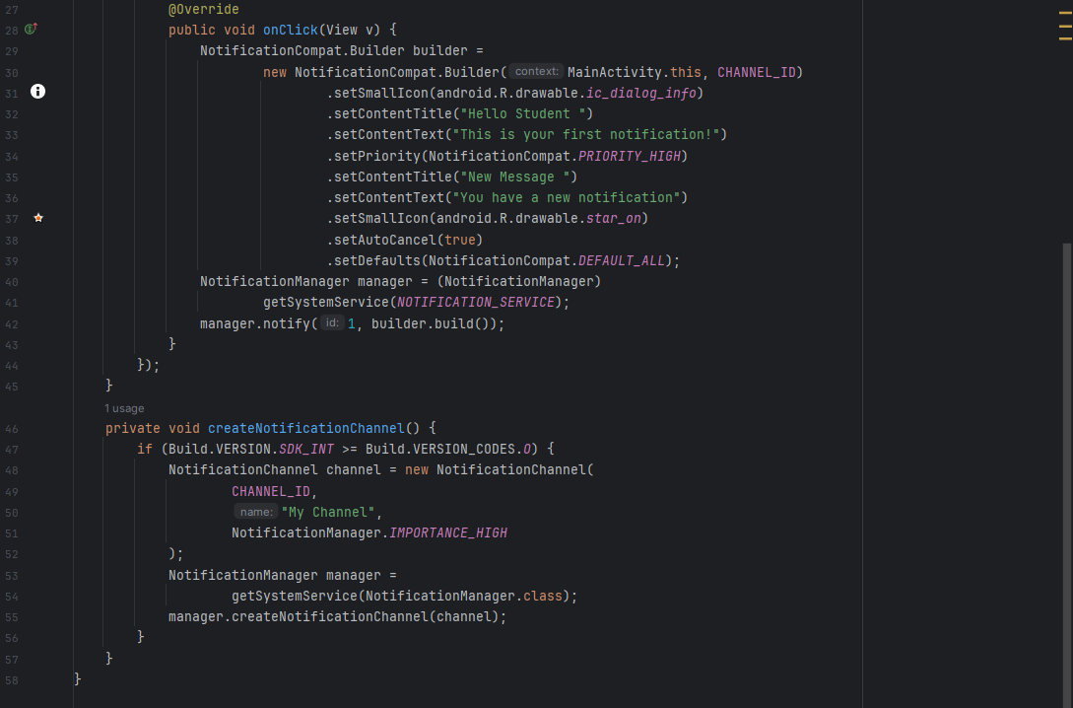

AndroidMenifest.xml
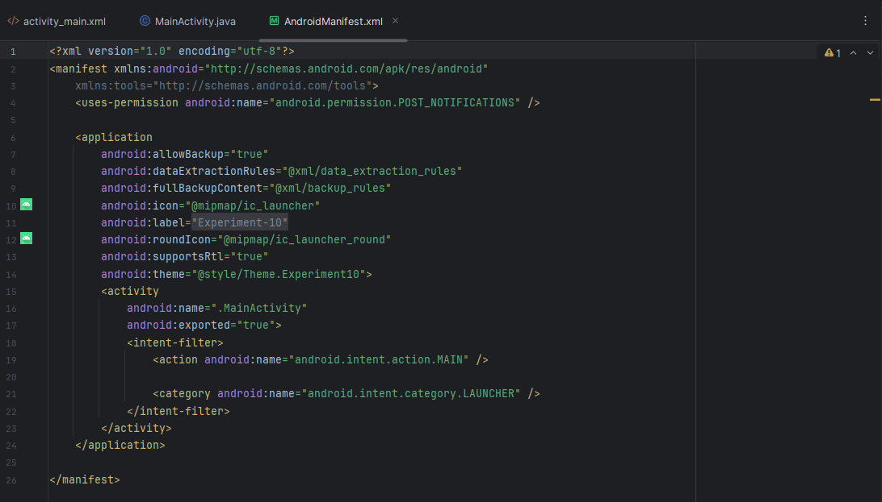

Output:
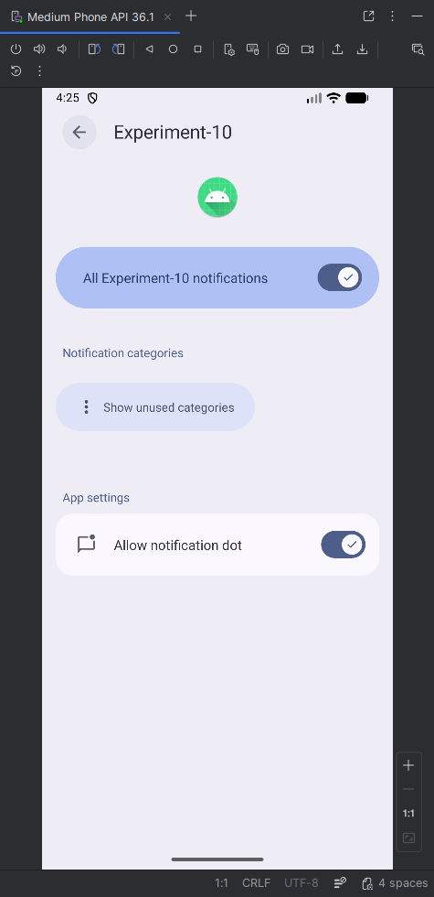 | 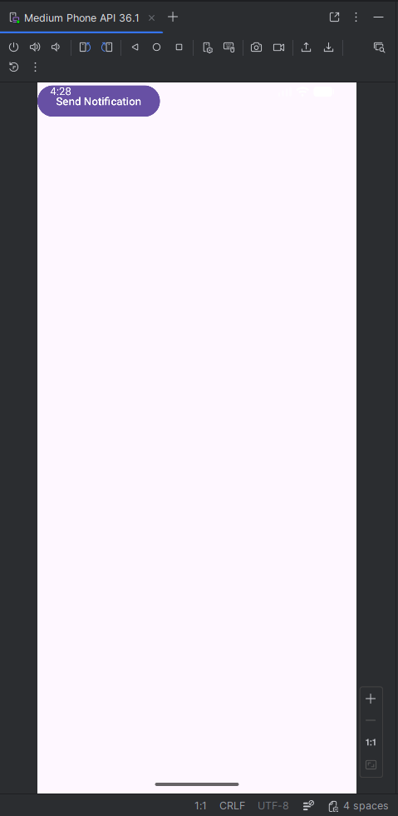 | 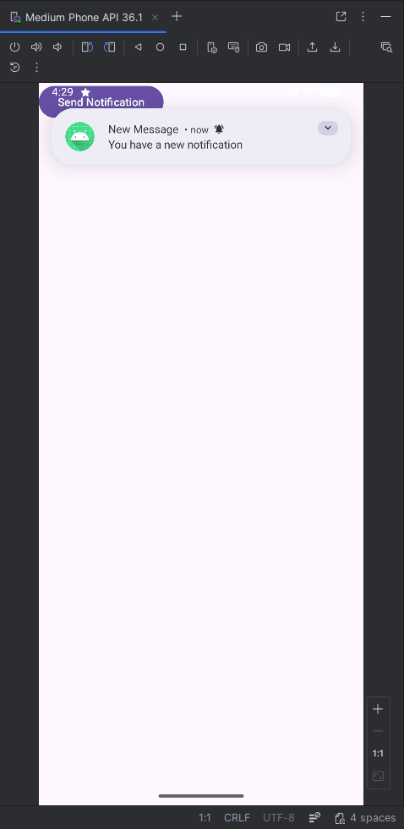

Conclusion:
This experiment demonstrated how to create and display notifications in an Android application using the Notification Manager. It also highlighted how to customize notification appearance and behavior using channels, styles, and priorities. Overall, it improved understanding of user engagement through effective alert mechanisms in Android apps.

